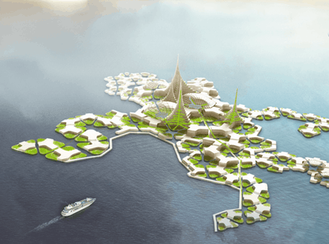
Week 7 Vocabulary: Floating Cities: One Group’s Idea for Adapting to Climate Change

coastline
habitat
foster
settlement
buoyant
self-sustaining
withstand
proposal
vulnerable
scarce
unconventional
architecture
low-rise
stack
mass-produced
cramped
venture
turbine
sheltered
weave

- the process, or profession, of designing buildings and their environments
- describes something that floats; also things that are fun and light
- the land that is next to an ocean, sea, or large lake

- describes something without a lot of space; packed together

- to care for and support something or someone
- the environment you are used to/accustomed to living in
- describes something that is not very tall; usually a building or pants
- describes things made on a large scale, usually in a factory

- an offer or suggestion

- describes when there isn't much of something
- describes being able to provide for your own needs without help from others

- a place where people live; usually a community that's smaller than a town
- describes when you are protected from danger or bad weather
- to put one thing on top of the other in an ordered pile
- a device used to generate energy using the power of water or wind moving a wheel

- describes when you act, dress, speak etc. in ways that are different than what most people consider normal
- to go somewhere possibly dangerous

- describes something or someone open to being physically or emotionally hurt
- to put together different strips of fabric or string to make something (like a rug or a blanket or a basket)

- to hold up (resist) against something strong

