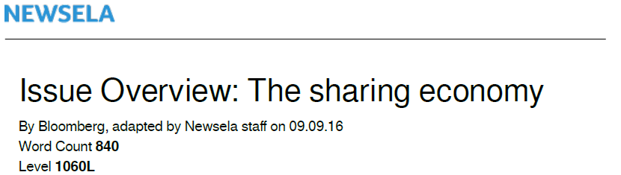
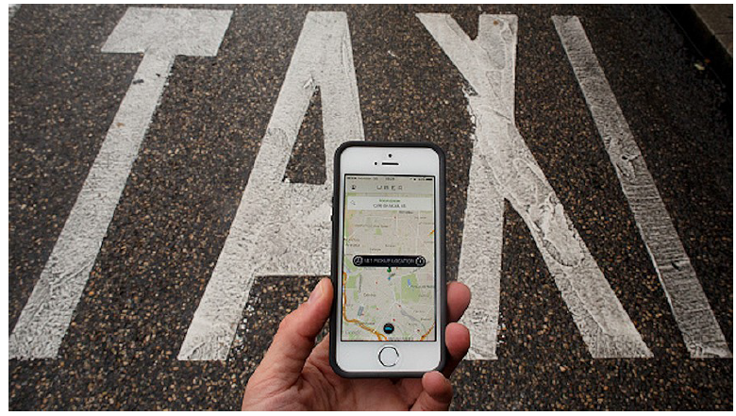
“The sharing economy” sounds like something noble. It suggests that while typical businesspeople sell, buy and rent, those in a sharing economy work together, build trust and make things easier for everyone. Or so they say.
Sharing-economy companies like Uber, Airbnb and Homejoy say they give everyday people the chance to find extra work. They claim they give people the opportunity to make money from things that would otherwise go unused — such as their car or an extra room. Customers are able to get products and services cheaply and easily, without the burdens of ownership. Thanks to them, the companies say, buyers and sellers can now easily connect.

Fans of the sharing economy say it brings social benefits, like community building and less economic inequality. On the other hand, critics predict it is more likely to lower wages, raise housing costs, undermine health and safety rules and put women at risk of being assaulted. A 2015 Harvard Business Review headline said: “The Sharing Economy Isn’t About Sharing at All.”

The Situation

Investors have poured money into sharing-economy companies even though most are not yet profitable. In 2014, investments totaled $4.1 billion, while in 2015 they rose to $17.9 billion.
Uber, a company that connects people with cars and people who need rides, raised $1 billion in July 2015, based on the idea it was worth $50 billion. This is as much as Target, the giant department store chain, is worth. By December, Uber's valuation was up to $62.5 billion. In June 2016, Airbnb, which helps people rent out their homes to short-term visitors, began a new round of fundraising at a valuation of $30 billion.

The sharing-economy companies have faced legal challenges, however. For example, in both
Massachusetts and California, Uber has faced lawsuits over the legality of its drivers, who do not have cab licenses. In France, Uber has faced everything from violent protests to fines imposed on its executives.

In a different kind of setback, Uber sold its China operations in July to its rival company Didi Chuxing. The sale was seen as a way to end an expensive price war with the Chinese ridehailing company. Didi had been trying to lure Chinese riders by charging less than Uber.

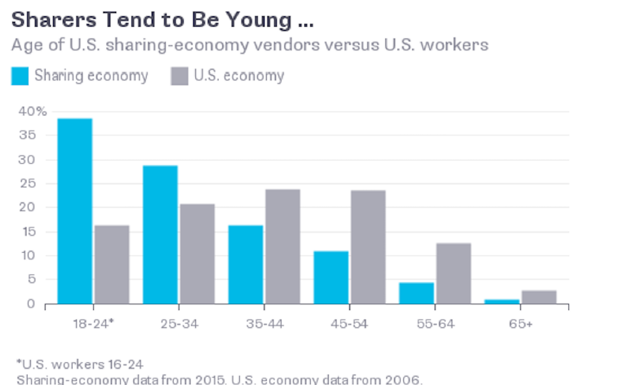
Mayors of cities from New York to Seoul have joined together to produce a common set of rules and regulations. Their hope is that clear and uniform laws will help them rein in the big sharing-economy companies.

Meanwhile, new economy-sharing companies are popping up. For instance, dogs can now share homes too via DogVacay. The company lists 25,000 pet sitters on its site.

The Background

Some type of sharing economy has been around for years. So what is new about today's situation? The answer: smartphones.

Today’s sharing economy got its start in 2008, when Apple introduced its App Store.

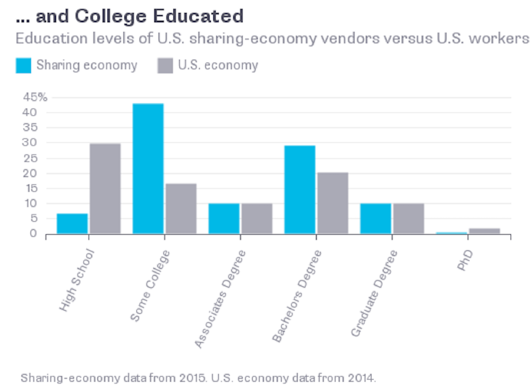
Suddenly, it was easy to quickly summon someone who wanted to work. TaskRabbit, founded that same year, became one of the earliest sharing-economy companies, connecting people looking for work with others looking to avoid chores. The task might be something unpleasant, like cleaning dead fish out of a tank. Or, it could simply be a chore someone did not have the time or expertise to handle.

Smartphones make it easier than ever for companies to manage a decentralized workforce. They also make it easier for companies to monitor the performance of workers through rating systems.

Growth in the sharing economy has also been aided by current economic conditions. More people seem to be looking for work these days.

The Argument

Critics say the sharing economy hurts employees by taking away basic workers' rights.
Workers go without benefits like health insurance or vacation time. They have no employment guarantees and could lose their jobs at any time.

Critics also claim the sharing economy is worsening economic inequality. In big cities, for example, apartments used for sharing become unavailable to long-term renters. With fewer apartments on the market, rents go up and housing becomes even harder to afford.

Businesses like taxi companies and hotels, which compete with Uber and Airbnb, say the sharing-economy companies have an unfair advantage. They do not have to follow the same regulations and do not have the same expenses. In addition, investors support them with huge amounts of cash.

On the flip side, sharing-economy companies make it easier for poorly paid workers to add to their incomes. Sharing also offers an escape from regimented office life and rigid working hours.

As sharing-economy companies adjust to regulators, they become more like other businesses.
For example, Houston now makes Uber drivers follow some of the same regulations taxi drivers are required to follow. They have to pass a background check and must make their cars suitable for the disabled.

However, Uber's sale of its China operations to Didi points to what could be a troubling future. Many smaller sharing-economy companies could end up being absorbed into larger ones. A few powerful companies may end up dominating their fields, making the notion of "sharing" much less convincing.

