Introvert or Extrovert. Which One Are You?
From VOA Learning English, this is the Health & Lifestyle report
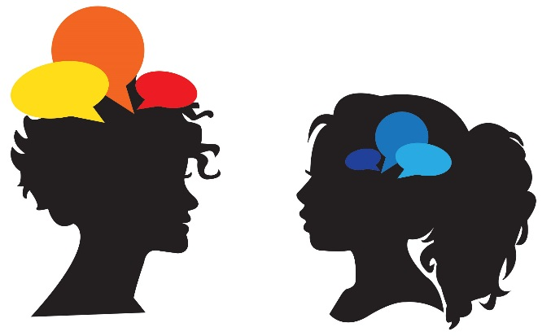
November 02, 2015

You are invited to a large party. Loud music is playing, and lots of people are dancing. Groups of people are mingling with each other, making small talk about many different topics.
What do you do? Do you mingle all night and talk to as many people as you can? Later, you cannot fall asleep -- you want more conversation!
Or do you prefer to have one-on-one conversations with just a few people? Maybe you find a quiet corner and people-watch. Or perhaps you cannot wait to go home early and relax by yourself.
Which of these people sound most like you? Person A, who tries to talk to everyone and stays late? Or Person B, who prefers to talk to only a few people and leaves early?
If you said Person A, you are probably more extroverted. If you said Person B, you are probably more introverted. Or perhaps you are Person C and fall somewhere in the middle.
Introvert vs. extrovert
Introvert and extrovert are two commonly used words to describe a person’s personality. And they are also commonly misused and misunderstood.
Introverts may be viewed as quiet, shy and timid. They may be called “wallflowers,” meaning they are so quiet they blend in with flowers on the wallpaper.
Extroverts may be viewed as bold, confident, loud and full of energy. They are often called “alpha,” meaning a leader of the group.
Introverted and extroverted people may fit those descriptions. But these same descriptions do not define introversion and extroversion properly.
Introverts and extroverts use their brains differently, and they get their energy differently. Introversion is the state of being mostly concerned with one's own mental life. Extroversion is the opposite. Extroversion is the state of being mostly concerned with what is outside oneself.
People who consider themselves introverts may say they “need to be alone to “charge their batteries” or that being in large crowds makes them tired. However, introverts may still love being social and going to parties. But such activities require time to prepare and time to repair.
Extroverts may say, “I don’t need ‘alone time.’ I feel more relaxed being around other people.” Even so, extroverts can still feel unsure or not confident among other people.
The power of introverts
Susan Cain is the author of “Quiet: The Power of Introverts.”
In an article published in Psychology Today, she explains that shyness is often considered a synonym of introversion. It is not. Shyness is having a fear of being judged poorly by others. Introverts just prefer being in quiet environments.
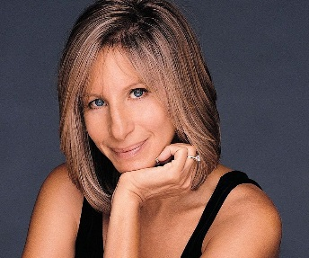
For example, Bill Gates, the inventor of Microsoft, is quiet and bookish, she writes. But Gates does not care about the opinions other people may have of him. He is an introvert, writes Cain, but he is not shy.
Bill Gates, creator of Microsoft, is an introvert but not shy.
The famous singer and actor Barbara Streisand has an outgoing, larger-than-life personality, adds Cain. But Barbara Streisand, she writes, also has a paralyzing case of stage fright. This is a commonly used fixed expression. Performers who suffer from stage fright can quite literally be frozen or paralyzed on stage.
Cain considers Barbara Streisand a shy extrovert.
Barbra Streisand is a shy extrovert.
In other words, there are nervous introverts and calm extroverts. And there are also shy extroverts and bold introverts. And there are many other combinations in between.

